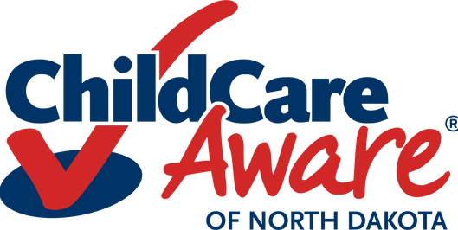

Orientation Checklist

*Please use this sample staff orientation checklist as a template. You may cut, copy, and paste as needed. Please note that the list is not all inclusive and your checklist may have different items included. Items in red are required by ND Early Childhood Services Rule to be addressed in the first week of work.*

Employee Name: Classroom:

Date Hired: Supervisor:

# Pre-Hire

|  |  |  |
| --- | --- | --- |
| Date Covered | Employee Initials Verifying Understand Policy/Procedure | Date Completed |
|  |  |  |
|  |  |  |
|  |  |  |
|  |  |  |
|  |  |  |
|  |  |  |
|  |  |  |
|  |  |  |
|  |  |  |
|  |  |  |
|  |  |  |
|  |  |  |
|  |  |  |
|  |  |  |
|  |  |  |

Complete Background Check Complete Finger Printing

Job Expectations

Parking, Dress Code, Storage of Personal Items

# Onboarding

Complete Necessary HR Paperwork Insurance/Benefits

Pay Schedule/Direct Deposit

Staff Emergency Contact Information

Set Up Individual Growing Futures Account Getting Started

Mandated Reporter Safe Sleep Training CPR/First Aid

# Two-Day Required Orientation

|  |  |  |
| --- | --- | --- |
| Date Covered | Employee Initials Verifying Understand Policy/Procedure | Date Completed |
|  |  |  |
|  |  |  |
|  |  |  |
|  |  |  |
|  |  |  |
|  |  |  |
|  |  |  |
|  |  |  |
|  |  |  |
|  |  |  |
|  |  |  |
|  |  |  |
|  |  |  |
|  |  |  |
|  |  |  |
|  |  |  |
|  |  |  |
|  |  |  |
|  |  |  |
|  |  |  |
|  |  |  |
|  |  |  |
|  |  |  |
|  |  |  |
|  |  |  |
|  |  |  |
|  |  |  |

Tour of Facility

Introduction to Staff Members Review of Staff Handbook

*Attendance Policy Overtime*

*Paid Time Off*

*Extended Leave Policy Keys/Access to Building Employment at Will*

*Cell Phone Policy*

*Appropriate Use of Technology (Computer, Facebook, Cameras, etc.)*

*Timecard*

*Conflict Resolution Process Individual Performance Evaluation Grievance Policy*

Review of Parent Handbook Family Custody Issues

Review ND Early Childhood Services Rule Confidentiality of Records, Information, and Photos Handwashing and Sanitation Procedures

Emergency Health, Fire and Safety Procedures, Handling and Storage of Hazardous Materials

Medication Administration Policies Child Abuse and Neglect Laws

Process for Reporting a Complaint or Suspected Licensing Violation

Individual Child Needs - Health, Nutrition, Special Needs Transportation and Child Passenger Safety, if Applicable Record Keeping Expectations

# Ongoing Orientation

|  |  |  |
| --- | --- | --- |
| Date Covered | Employee Initials Verifying Understand Policy/Procedure | Date Completed |
|  |  |  |
|  |  |  |
|  |  |  |
|  |  |  |
|  |  |  |
|  |  |  |
|  |  |  |
|  |  |  |
|  |  |  |
|  |  |  |
|  |  |  |
|  |  |  |
|  |  |  |
|  |  |  |
|  |  |  |
|  |  |  |
|  |  |  |

Behavior Guidance Policy Supervision Policy

Adult-Child Interaction Policy

Overview of Growing Futures

 Link Individual to Employer Org Account Familiarize Self with Children’s Personal Files Curriculum Overview and Expectations North Dakota Early Childhood Standards Daily/Weekly Schedule

Planning Time/Lesson Plan/Activity Expectations Environment Set-Up

Transitions Between Activities Observation Expectations Assessment Used

Referral Process for Children with Health or Developmental Concerns

Family Partnership Expectations Conferences

Contact with Families Outside of Work Time/Babysitting

## I understand and agree to abide by the policies, guidelines, and procedures discussed.

(Staff Signature) (Date)

## I verify that the policies, guidelines, and procedures listed above were discussed and will be upheld.

(Supervisor Signature) (Date)

*Copy form and give to staff member. File original is staff’s personnel file. Revised 2/2025*