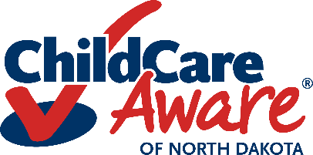
Inclusive Care Plan:
(Child’s First and Last Name)

Child’s Birth  Date |  | Child’s Height |  | Child’s Weight

Parent’s (Guardian) Name |  | Cell Phone Number
 |  | Work/Home Number
Emergency Contact Person  (Name/Relationship) |  | Phone Number
Primary Health Care Provider |  | Phone Number
Specialty Provider |  | Phone Number

Child Health Information: (Please attach additional information/documentation as needed)
My child has a special health care need or  diagnosis: Yes No | If yes, please specify
Allergies:  Yes No | If yes, please  specify
Medication Needs:  Yes No | If yes, please specify
Diet/Feeding Needs:  Yes No | If yes, please specify
Sleeping Needs:  Yes No | If yes, please specify
Toileting Needs:  Yes No | If yes, please specify
Equipment/Medical Supply Needs:  Yes No | If yes, please specify
Other Needs:  Yes No | If yes, please specify

Child Developmental Information: (Please attach additional information/documentation as needed)
My child has special developmental needs:  Yes No | If yes, please specify
Developmental Accommodations Needed:  Yes No | If yes, please specify
Additional Developmental
Information

Care Plan Page 2

Child Behavioral Information: (Please attach additional information/documentation as needed)

My child has special behavioral needs:  Yes No | If yes, please specify
Possible Causes/Purposes for Behavior: | - NA  - Tension Release  - Frustration  - Attention Getting  - Access to Restricted Items |  | - Escape  - Poor Self Regulation Skills  - Developmental Disorder  - Neurological  - Other:
Behavioral Accommodations Needed:  Yes No | If yes, please specify
Specific Equipment Needs Related to Behavior:  Yes No | If yes, please specify
Additional Information regarding behavioral needs:
Other important Information about child:

Child receives additional services related to medical, developmental, or behavioral needs. (Early Intervention, Outpatient Therapy, Psychological Services, Regular Medical Follow up, School Special Education Services, etc.). Yes No
If yes, please list:

Staff need the following training, related to medical, developmental, or behavioral needs, to care for child:

Consent for health care or other provider to communicate with my child’s child care provider to discuss information relating child’s medical or behavioral needs. □Yes □No □NA

Date Plan Written: Date to Review Plan:

Health Care (or other provider) Signature Parent/Guardian Signature Child Care Provider Signature
Date: Date: Date:

Form provided by CCA of ND Health & Safety Specialists.
Revised 6/23
Child Care Aware® of North Dakota grants users’ permission to reproduce this document for educational purposes.

