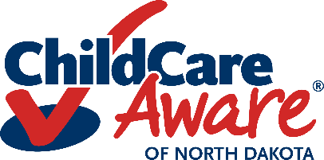
Care Plan Tracking
Use this form to ensure all children who have a diagnosed condition have a care plan and it is updated at least yearly.

Child’s Name | Classroom | Health Concern | Date  Care Plan Complete | Date  Care Plan Updated |  |  |  | Release of  Information Form Signed

Form provided by Child Care Aware® of North Dakota Health & Safety Specialists Revised 6/23
Child Care Aware® of North Dakota grants users’ permission to reproduce this document for educational purposes.

