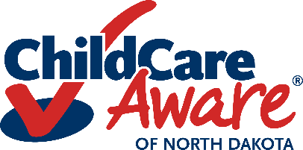
Child Care Aware Consent for Authorization and Disclosure
This release of Information allows Child Care Aware employees to provide support, related to your child’s needs, to your child care provider/program and/or service provider. This support may consist of assisting your child care provider/program in implementing routines, accessing resources, and adapting the environment in the best way possible to meet the needs of your child.

Child’s Name
Date of Birth
Parent/Guardian’s Name
Address
Phone/Email

Name of Child Care Program
Name of Child Care Provider
Address of Child Care Provider/Program

I hereby authorize Child Care Aware of North Dakota employees to release information to and/or receive information from _______________________and/or __________________________________ .

(Child Care Program/Provider) (Service Provider)

Description of information to be Used or Disclosed:
Educational/Developmental Records (IEP/IFSP)
Diagnostic Assessments/Evaluations
Medical/Health Information (Care Plan)
Other:___________________________

Purpose of the Use or Disclosure:
The information will be used for the limited purpose of understanding and supporting the above-named child’s needs.
- I understand I may discontinue this authorization at any time by providing written notice to Child Care Aware of North Dakota. Discontinuation will not affect any actions that Child Care Aware took before it received the discontinuation.
- This authorization will remain in effect while the above-named child is enrolled in the above named child care program.
I authorize the use and disclosure of my child’s information as described above. I understand this authorization is voluntary. I understand that if the individual or organization receiving the information is not a health care provider or health plan covered by federal privacy regulations the information described above may be re-disclosed and no longer protected by these federal regulations. I understand that if I sign this form, I have the right to receive a copy of it. I understand I may decline to sign this authorization.
Parent/Guardian Signature: Date: Parent/Guardian Signature: Date:

Revised 6/23

